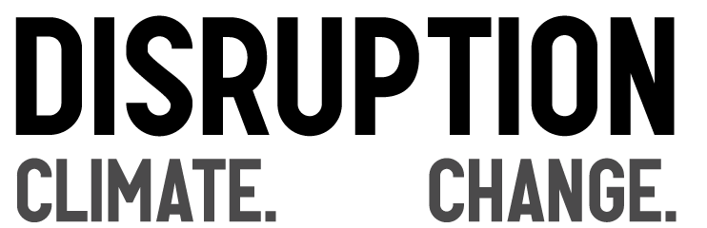

What: Join us for a free screening of “Disruption”, a new, fast-paced cinematic journey through the wild world of climate change: the science, the politics, the solutions, and the stories that define this crisis at this pivotal point in human history.
The movie is about an hour long, and after we watch it we’ll have a discussion about what we can all do together on this important issue.

When: ____________________________________

Where: ___________________________________

www.watchdisruption.com

